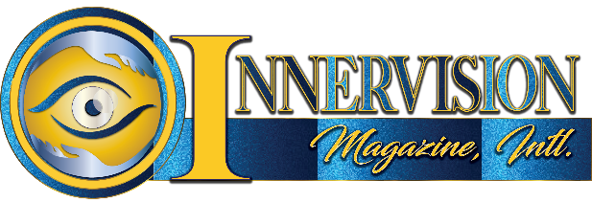
2nd Annual Pinnacle Awards Sponsorships
PLEASE CHECK YOUR LEVEL OF INTEREST
 | EVENT SPONSOR | $7,000
 | MASK SPONSOR | $5,000
 | GOWN SPONSOR | $3,500
 | TOP HAT SPONSOR | $1,500
 | BLING-BLING SPONSOR | $500

Sponsor Deadline is September 1st
ALL SPONSORSHIP LEVELS WILL INCLUDE LOGO AND LINK ON THE INNERVISION MAGAZINE WEBSITE.
$7000 EVENT SPONSOR – anthology issue cover story branding with feature article, 2 gala tables of 10, exclusive 30-minute interview on TV Show A Name to Know, logo and link on Innervision Magazine, Intl. websites and red-carpet host and speak on feet at podium.
$5,000 MASK SPONSOR – anthology issue back cover branding with feature article, 1 gala table of 10, exclusive 15-minute interview on TV Show A Name to Know, logo and link on Innervision Magazine, Intl. websites and speak on feet at podium.
$3,500 GOWN SPONSOR – anthology full page color ad with feature article, exclusive 10-minute interview on TV Show A Name to Know, 5 gala seats and podium mention.
$1,500 TOP HAT SPONSOR – anthology full page color ad with feature article, exclusive 10-minute interview on TV Show A Name to Know, 3 gala seats and podium mention.
$500 BLING-BLING SPONSOR – anthology ½ page color ad with feature article, 2 gala seats and podium mention.
Please fill and return to innervisionmagazine@gmail.com by September 1, 2023

Event supports children of incarcerated parents.

